
AP Biology
Unit 7: Natural Selection
Suggested Duration: 21 Days
NATURAL SELECTION
UNIT PLAN

Table of Contents
UNIT NARRATIVE 1
CONTENT STANDARDS 2
ROADMAP 4
UNPACKED STANDARDS 17
VOCABULARY GLOSSARY 23

UNIT NARRATIVE
The concepts in Unit 7 build on foundational content from previous units as students discover natural selection, a mechanism of evolution—the theory that populations that are better adapted to their environment will survive and reproduce. Thus, the evolution of a species involves a change in its genetic makeup over time. In this unit, students study the evidence for and mechanisms of evolutionary change. Students also learn what happens when a species does not adapt to a changing or volatile environment and about the Hardy-Weinberg equilibrium as a model for describing and predicting allele frequencies in nonevolving populations. Students will learn to calculate and draw conclusions about the evolution, or lack thereof, of a population from data related to allele frequencies.

By now, students should be accustomed to using visual models and representations to explain or illustrate biological processes. This unit provides students with the opportunity to gain proficiency in describing a given model or representation and communicating the biological meaning it represents. Mastery is demonstrated when students can create or use models such as cladograms and phylogenetic trees to communicate biological phenomena, analyze situations, or solve new problems. Hardy-Weinberg equations are used with respect to a specific gene. Thus, when teaching students how to use the equations, be careful to distinguish between allele and genotype frequencies. The Hardy-Weinberg principle clarifies the factors that alter allele frequency, but it does not imply that allele frequencies are static. This is an important understanding that students need in order to make predictions about a change in a population and to justify the reasoning for their predictions.

The principle of natural selection and its components appears throughout the course. It is important that students are precise in the language they use when writing about evolution, being careful to avoid writing statements that are Lamarckian. A common student error is using buzzwords such as “fitness” without proper explanation of the underlying concept. Students should recall the sources of genetic variation learned in Unit 5 in order to demonstrate the understanding that genetic variation is necessary for natural selection and describe its role in reproductive success. In their writing, students should be clear that while natural selection acts on individuals, it is populations that evolve. Another common error on the exam is that students do not clearly differentiate the types of reproductive isolating mechanisms that lead to speciation.

UNDERTANDINGS AND CONTENT STANDARDS
Below are the standards taught and assessed in this unit.
Topic
- Enduring Understanding
  - Learning Objectives (Students will be able to…)
Topic 7.1 – Introduction to Natural Selection
- Big Idea 1 – Evolution: The process of evolution drives the diversity and unity of life.
  - 7.1.A: Describe the causes of natural selection.
  - 7.1.B: Explain how natural selection affects populations.
Topic 7.2 – Natural Selection
- Big Idea 1 – Evolution: The process of evolution drives the diversity and unity of life.
  - 7.2.A: Describe the importance of phenotypic variation in a population.
  - 7.2.B: Explain how variation in molecules within cells connects to the fitness of an organism.
Topic 7.3 – Artificial Selection
- Big Idea 1 – Evolution: The process of evolution drives the diversity and unity of life.
  - 7.3.A: Explain how humans can affect diversity within a population.
Topic 7.4 – Population Genetics
- Big Idea 1 – Evolution: The process of evolution drives the diversity and unity of life.
  - 7.4.A: Explain how random occurrences affect the genetic makeup of a population.
  - 7.4.B: Describe the role of random processes in the evolution of specific populations.
  - 7.4.C: Describe the change in the genetic makeup of a population over time.
Topic 7.5 – Hardy-Weinberg Equilibrium
- Big Idea 1 – Evolution: The process of evolution drives the diversity and unity of life.
  - 7.5.A: Describe the conditions under which allele and genotype frequencies will change in populations.
Topic 7.6 – Evidence of Evolution
- Big Idea 1 – Evolution: The process of evolution drives the diversity and unity of life.
  - 7.6.A: Describe the types of data that provide evidence for evolution.
  - 7.6.B: Explain how morphological, biochemical, and geological data provide evidence that organisms have changed over time.
Topic 7.7 – Common Ancestry
- Big Idea 1 – Evolution: The process of evolution drives the diversity and unity of life.
  - 7.7.A: Describe structural and functional evidence on cellular and molecular levels that provides evidence for the common ancestry of all eukaryotes.
Topic 7.8 – Continuing Evolution
- Big Idea 1 – Evolution: The process of evolution drives the diversity and unity of life.
  - 7.8.A: Explain how evolution is an ongoing process in all living organisms.
Topic 7.9 – Phylogeny
- Big Idea 1 – Evolution: The process of evolution drives the diversity and unity of life.
  - 7.9.A: Describe the types of evidence that can be used to infer an evolutionary relationship.
  - 7.9.B: Explain how a phylogenetic tree and/or cladogram can be used to infer evolutionary relatedness.
Topic 7.10 – Speciation
- Big Idea 1 – Evolution: The process of evolution drives the diversity and unity of life.
  - 7.10.A: Describe the conditions under which new species may arise.
  - 7.10.B: Describe the rate of evolution and speciation under different ecological conditions.
  - 7.10.C: Explain the processes and mechanisms that drive speciation.
Topic 7.11 – Variations in Populations
- Big Idea 4 – Systems Interactions: Biological systems interact, and these systems and their interactions exhibit complex properties.
  - 7.11.A: Explain how the genetic diversity of a species or population affects its ability to withstand environmental pressures.
Topic 7.12 – Origins of Life on Earth
- Big Idea 4 – Systems Interactions: Biological systems interact, and these systems and their interactions exhibit complex properties.
  - 7.12.A: Describe the scientific evidence that provides support for models of the origin of life on Earth.

Key Questions
- What is evolution?
- What is an adaptation?
- What is natural selection?
- What is artificial selection?
- What is population genetics?
- How does the Hardy-Weinberg Equilibrium and equations help to investigate the presence of evolution or not?
- What is the difference between the following types of evolution: gene flow, genetic drift, and mutation?
- What is phylogeny?
- What does “common ancestry” mean?
- What is a cladogram?
- How do you use a phylogenetic tree?
- What are the different pieces of evidence that supports the Earth’s age and early characteristics?
- How do populations vary over time?
- What are the different types of evidence that are used to support the concept of evolution?
- What is punctuated equilibrium, and how is it different from gradualism?
- What is speciation?
- What is extinction?

ROADMAP
 | Lessons #1 and #2: Cottontails Activity |  | Date:
 | Objective  SWBAT: Investigate how a population evolves over time due to random mutations and environmental pressures.  Standards  Topic 7.1: Into. To Natural Selection  Topic 7.2: Natural Selection  Vocabulary  adaptation  fitness  natural selection  population  adaptation  environmental resource  fitness  inherited variation  natural selection  reproductive success  mutation  Science Practices  - Concept Explanation  - Visual Representations  - Questions and Methods  - Representing and Describing Data  - Statistical Tests and Data Analysis  - Argumentation | Instructional Notes  This activity is designed to introduce the concept of natural selection. One of the main points of this activity is to help students see that a single organism cannot adapt to its environment, but that it will survive if it possesses a beneficial  adaptation. The data collected in this activity can be used as a reference point for terms used during presentations on evolution and speciation.  Day 1: Students participate in a guided inquiry activity using a computer simulation to investigate the survivability of a population of “bunnies” under several different mutations and population limiting factors.  Day 2: Students continue using the Natural Selection simulation from PhET, but today they are creating their own question and using the simulation to test it out.  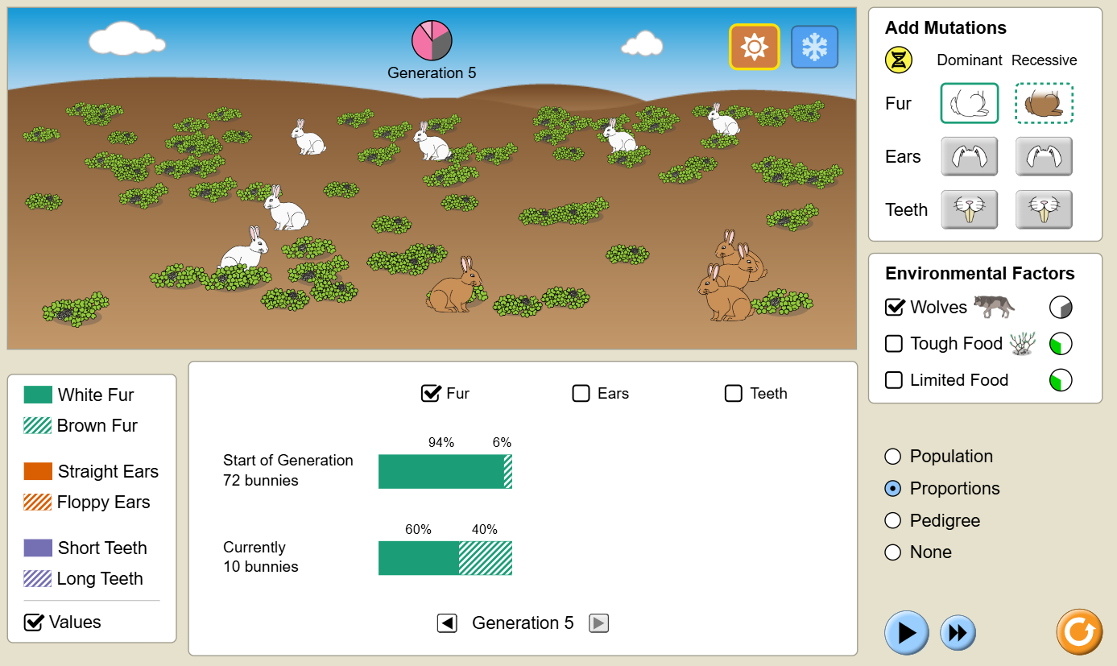 |  | Lesson Look Fors  Look for teachers to:  - Allow students to productively struggle with the content, using accountable talk moves to facilitate the lesson.  - Asking probing questions throughout the presentation that pushes students’ thinking.  Look for students to:  - Ask clarifying questions regarding what they are learning  - Write in complete sentences  Students Do and Know
   | - Analyze data and identify trends.  - Collaborate with peers to discuss similarities and differences in conclusions that were made.
   | - An adaptation is a trait that an individual is born with that either gives it an advantage or disadvantage in an environment.  - Evolution is a change in gene frequencies in a population over time.  - Natural selection is a type of evolution where certain traits (adaptations) give some populations reproductive success.  - Fitness is the ability to produce children.  - A population is a group of individuals of the same species.  - A mutation is change in the nucleotide sequence in DNA that may or may not produce a new trait.
 | Lesson #3: Population Variation Determination |  | Date:
 | Objective  SWBAT: Investigate, using collected data, how a population might change due to one or more types of natural selection.  Standards  Topic 7.2: Natural Selection  Vocabulary  adapt/adaptation  competition  diversity  gene frequency  habitat  mortality rate  natural selection  offspring  population  predator  prey  reproduction  stabilizing selection  disruptive selection  directional selection  Science Practices  - Concept Explanation  - Visual Representations  - Representing and Describing Data  - Argumentation | Instructional Notes  In this activity, students take measurements on plant and student traits and perform calculations to examine the dispersion of the data. They will then construct a histogram of the class hand length data and use it to predict the outcome (graphically) of three scenarios involving the three modes of natural selection (stabilizing, directional, and disruptive).  Students will:  - Collect and statistically analyze leaf variation data  - Collect and statistically analyze hand variation data  - Make a histogram of hand data and use it to predict changes to the population due to different modes of natural selection  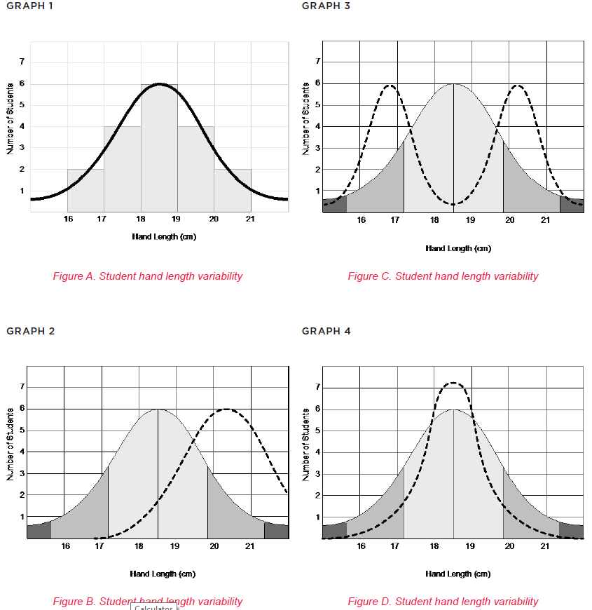 |  | Lesson Look Fors  Look for teachers to:  - Allow students to productively struggle with the content, using accountable talk moves to facilitate the lesson.  - Asking probing questions throughout the presentation that pushes students’ thinking.  Look for students to:  - Ask clarifying questions regarding what they are learning  - Write in complete sentences  Students Do and Know
  - Collect data.
  - Create models of data.
  - Analyze graphs for trends.
  - Natural selection is a type of evolution where certain traits (adaptations) give some populations reproductive success.
  - A population is a group of individuals of the same species.
  - Stabilizing selection is a type of natural selection that favors individuals with average or moderate traits and selects against extreme traits.
  - Disruptive selection is a type of natural selection where individuals with extreme traits are favored over those with intermediate traits.
  - Directional selection is a type of natural selection that occurs when a population favors one extreme phenotype over other phenotypes.
 | Lessons #4 – Artificial Selection |  | Date:
 | Objective  SWBAT: Model the effects of artificial selection on a population.  Standards  Topic 7.3: Artificial Selection  Vocabulary  Natural Selection  Artificial Selection  Breed  Chromosome  Evolution  Fitness  Genotype  Phenotype  Mutation  Science Practices  - Concept Explanation  - Visual Representations  - Representing and Describing Data  - Argumentation | Instructional Notes  Activity #1: Students will watch a video on coevolution and convergent evolution.  Activity #2: Artificial Selection Gizmo  Students will …  - Use artificial selection to develop a new variety of insects.  - Distinguish between the processes of natural and artificial selection.  - Compare the rates at which natural and artificial selection occur.  - Explore how the rate of mutations is related to the rate of adaptation to an environment.  The Evolution: Natural and Artificial Selection Gizmo allows students to explore the process of artificial selection and compare its outcomes to the results of natural selection.  The Student Exploration sheet contains three activities:  - Activity A – Students see how inheritance, mutation, and selection lead to evolution.  - Activity B – Students compare the processes of natural and artificial selection.  - Activity C – Students investigate how the mutation rate affects evolution. |  | Lesson Look Fors  Look for teachers to:  - Allow students to productively struggle with the content, using accountable talk moves to facilitate the lesson.  - Asking probing questions throughout the presentation that pushes students’ thinking.  Look for students to:  - Ask clarifying questions regarding what they are learning  - Write in complete sentences  Students Do and Know
  - Analyze data and identify trends.
  - Collaborate with peers to discuss similarities and differences in conclusions that were made.
  - Evolution is a change in gene frequencies in a population over time.
  - Natural selection is a type of evolution where certain traits (adaptations) give some populations reproductive success.
  - Fitness is the ability to produce children.
  - A mutation is change in the nucleotide sequence in DNA that may or may not produce a new trait.
  - Phenotype is the physical appearance of a trait.
  - Genotype is the makeup of the alleles that code for the phenotype.
Lessons #5 – Hardy Weinberg Equilibrium |  |  | Date:
Objective  SWBAT: Investigate whether evolution has occurred in a population by measuring the change in gene frequencies over time.  Standards  Topic 7.4: Population Genetics  Topic 7.5: Hardy-Weinberg Equilibrium  Vocabulary  Allele  Genotype  Hardy-Weinberg Equilibrium  Heterozygous  Homozygous  Incompletely dominant  Punnett square  Science Practices  - Concept Explanation  - Visual Representations  - Representing and Describing Data  - Statistical Tests and Data Analysis  - Argumentation |  | Instructional Notes  Students will …  - Observe that allele ratios tend to remain constant in a randomly-mating population.  - Determine that the ratios of genotypes also tend to remain nearly constant in a randomly-mating population.  - Measure the ratio of heterozygous to homozygous individuals in a population and see that this ratio remains fairly constant over time.  - Use the Hardy-Weinberg equation to calculate the percentages of genotypes in a population.  Many factors can influence the frequencies of different alleles and genotypes in a population. Predation, sexual selection, immigration, disease, competition, or natural selection may cause some alleles to become more common and others to become less common.  To understand if a population is being influenced by one of these factors, it is first necessary to understand how a population reacts if none of these factors are present. The Hardy-Weinberg Equilibrium Gizmo allows students to explore how the proportions of alleles and genotypes change over time in a population that is not undergoing any form of selection.  The Student Exploration sheet contains three activities:  - Activity A – Students discover that in normal circumstances allele and genotype percentages tend to remain stable over time.  - Activity B – Students derive the Hardy-Weinberg equation and use it to calculate genotype and allele percentages.  - Activity C – Students explore a useful ratio that is constant in equilibrium populations. |  | Lesson Look Fors  Look for teachers to:  - Allow students to productively struggle with the content, using accountable talk moves to facilitate the lesson.  - Asking probing questions throughout the presentation that pushes students’ thinking.  Look for students to:  - Ask clarifying questions regarding what they are learning  - Write in complete sentences  Students Do and Know
  - Analyze data and identify trends.
  - Collaborate with peers to discuss similarities and differences in conclusions that were made.
  - Evolution is a change in gene frequencies in a population over time.
  - Natural selection is a type of evolution where certain traits (adaptations) give some populations reproductive success.
  - Fitness is the ability to produce children.
  - A mutation is change in the nucleotide sequence in DNA that may or may not produce a new trait.
  - Genotype is the makeup of the alleles that code for the phenotype.
  - The Hardy-Weinberg equilibrium is a principle stating that the genetic variation in a population will remain constant from one generation to the next in the absence of disturbing factors.
 | Lessons #6 and #7: The Mating Games |  | Date:
 | Objective  SWBAT: Investigate how allele frequencies are changed over time due to different types of population changes (gene flow, genetic drift, and mutations).  Standards  Topic 7.4: Population Genetics  Topic 7.5: Hardy-Weinberg Equilibrium  Vocabulary  artificial selection  gene flow  genetic drift  genetic variation  mutation  non-random mating  recombination  Science Practices  - Concept Explanation  - Representing and Describing Data  - Argumentation | Instructional Notes  In this simulation, the students represent populations of heterozygotes that are manipulated. In the first mating game, students are involved in random mating of heterozygote individuals, and the second mating game involves isolating your class into three or more populations and thereby creating genetic drift. The third mating game involves gene flow, and the fourth mating game involves the introduction of a mutation into the population.  Students will:  - Simulate four different populations, each with different and distinct allele combinations  - Use the class data to calculate the genotypic frequency for each population in the four scenarios  - Calculate the frequency of each allele using information from the genotypic frequencies of each population  Day 5: Students will watch a video on the different types of evolution (gene flow, natural selection, genetic drift, and mutations). Then they will engage in a hands-on-minds-on activity where they simulate a population without evolution occurring, as well as a population undergoing genetic drift.  Day 6: Students will engage in the same activity as yesterday but today they will engage in simulating gene flow and the introduction of a mutation.  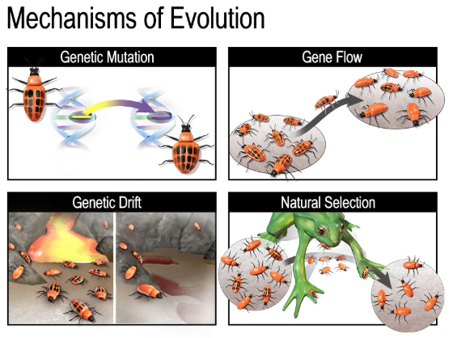 |  | Lesson Look Fors  Look for teachers to:  - Allow students to productively struggle with the content, using accountable talk moves to facilitate the lesson.  - Asking probing questions throughout the presentation that pushes students’ thinking.  Look for students to:  - Ask clarifying questions regarding what they are learning  - Write in complete sentences  Students Do and Know
  - Analyze data and identify trends.
  - Collaborate with peers to discuss similarities and differences in conclusions that were made.
  - Evolution is a change in gene frequencies in a population over time.
  - A population is a group of individuals of the same species.
  - A mutation is change in the nucleotide sequence in DNA that may or may not produce a new trait.
  - Gene flow is the movement of alleles into or out of a population.
  - Genetic drift is the when a population suddenly decreases in size and therefore the gene pool gets smaller and less diverse.

Lesson #8: Evidence for Evolution Activity |  | Date:
Objective  SWBAT: Investigate the different types of evidence used to support evolution.  Standards  Topic 7.6: Evidence of Evolution  Topic 7.7: Common Ancestry  Vocabulary  analogous structure  ancestor  biogeography  descended  developmental homology  DNA sequence  embryo  evolution  fossil record  genus  homologous structure  molecular homology  offspring  phylogenetic  Science Practices  - Concept Explanation  - Visual Representations  - Argumentation | Instructional Notes  The goal of this activity is for students to familiarize themselves with the different pieces of evidence used to support evolution over time.  Activity #1: Students watch a video that walks them through the different pieces of evidence.  Activity #2: Students participate in a paper-based activity where they investigate the different pieces of evidence below  - fossil record  - embryology  - comparative anatomy (morphology)  - vestigial structures  - molecular biology  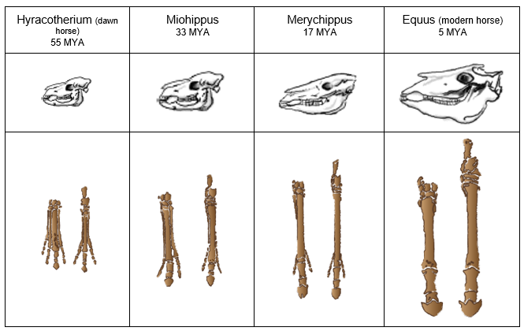 |  | Lesson Look Fors  Look for teachers to:  - Allow students to productively struggle with the content, using accountable talk moves to facilitate the lesson.  - Asking probing questions throughout the presentation that pushes students’ thinking.  Look for students to:  - Ask clarifying questions regarding what they are learning  - Write in complete sentences  Students Do and Know
  - Analyze data and identify trends.
  - Collaborate with peers to discuss similarities and differences in conclusions that were made.
  - The fossil record is a collection of fossils that documents the history of life on Earth.
  - Biogeography is the branch of biology that deals with the geographical distribution of plants and animals.
  - Homology is the study of similarities between organisms that are due to shared ancestry.
  - Anatomical homology deals with similarities and differences in morphology (anatomical traits.)
  - Developmental homology deals with embryological similarities and differences.
  - Molecular homology deals with similarities and differences in DNA, RNA, and proteins.

Lesson #9 – Variation in Populations and Continuing Evolution |  |  | Date:
Objective  SWBAT: Describe examples of real-world scenarios where evolution is still actively occurring.  Standards  Topic 7.8: Continuing Evolution  Topic 7.12: Variation in Populations  Vocabulary  Allele  Genetic diversity  Environmental pressure  Variation  Population  Science Practices  - Concept Explanation  - Visual Representations  - Argumentation |  | Instructional Notes  Activity #1: Students will read an article about how genetic diversity dictates a population’s ability to withstand environmental pressures, and how alleles that are adaptive in one environmental condition can be deleterious in another.  Activity #2: Students will read an article about how evolution happens all around us and how evolution is an “ongoing process” that permeates through all ecosystems on the planet.  Activity #3: Practice Questions:  For the multiple-choice practice questions, students will have to correctly answer the question AND they will have to provide a justification of why the correct answer is not correct and why the incorrect answers are not correct.  For the free response practice questions students will participate in highlight and rewrite activities. A HLRW activity is one where students answer a prompt, then highlight where they got points, analyze where they were correct and where they missed the mark, and then rewrite with a perfect response.  - Teacher hands student a free response prompt.  - Students answer the question to the best of their ability.  - Teacher gives students the rubric by which the question should be scored on and then takes a highlighter and highlights everywhere in their writing that earned a point. The teacher can help clarify if individual students have questions.  - Students then analyze their answer for the following:  - Where did I earn points, and why was I able to earn them?  - Where did I not earn points, and why was I not able to earn them?  - What vocabulary and/or concepts did I not know and/or got confused on?  - Then, the student takes their analysis, along with the rubric, and writes a perfect response. |  | Lesson Look Fors  Look for teachers to:  - Allow students to productively struggle with the content, using accountable talk moves to facilitate the lesson.  - Asking probing questions throughout the presentation that pushes students’ thinking.  Look for students to:  - Ask clarifying questions regarding what they are learning  - Write in complete sentences  Students Do and Know
  - Derive meaning from a Read to Learn.
  - Create written answers to AP Biology free response questions.
  - Evolution is a change in gene frequencies in a population over time.
  - Natural selection is a type of evolution where certain traits (adaptations) give some populations reproductive success.
  - Variation is the differences between individuals of the same species, caused by genetic and environmental factors.
  - Population diversity is the representation and relative size of different groups within a population.
  - The four main types of selection pressures are biological factors, such as predation and disease, availability of resources, climate, and competition.
  - Environmental pressures are factors that can cause environmental change, and can include human activities, climate change, ecological pressures, and stressful environmental conditions.
Lesson #10: The Great Clade Race |  |  | Date:
Objective  SWBAT: Design a cladogram of different species based on both shared and non-shared characteristics.  Standards  Topic 7.9: Phylogeny  Vocabulary  Cladogram  Homology  Ancestor  Evolution  Species  speciation  Science Practices  - Concept Explanation  - Visual Representations  - Argumentation |  | Instructional Notes  Cladistics is one of the most commonly used methods today for reconstructing evolutionary ancestries. For many students, an introductory lecture on cladistics comes across as an onslaught of strange new terms and opaque jargon. This activity is a simple puzzle to begin our introductory cladistics lessons that  allows students to use cladistic thinking without first bogging them down with terminology. This activity, called the Great Clade Race, students not only begin their approach to cladistics with a more positive attitude, but they also seem to have a better comprehension of what cladistics does and why cladistics is used.  Activity #1: Students organize cards, which have different characteristics into groups. They spar with other groups on whose grouping strategy is superior.  Activity #2: Students use a “racing challenge” to construct a cladogram using the characteristics found on the cards. The important aspect of this, as a teacher, to note is that each group’s cladogram does NOT have to look that same. They just need to be able to talk through why they chose to construct their cladogram the way they did and defend its validity.  Productive struggle is KEY during this activity.  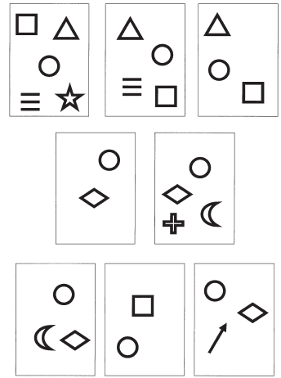 |  | Lesson Look Fors  Look for teachers to:  - Allow students to productively struggle with the content, using accountable talk moves to facilitate the lesson.  - Asking probing questions throughout the presentation that pushes students’ thinking.  Look for students to:  - Ask clarifying questions regarding what they are learning  - Write in complete sentences  Students Do and Know
  - Analyze data and identify trends.
  - Collaborate with peers to discuss similarities and differences in conclusions that were made.
  - An adaptation is a trait that an individual is born with that either gives it an advantage or disadvantage in an environment.
  - A cladogram is a diagram that shows the evolutionary relationships between organisms by grouping them into clades based on shared characteristics.
  - Homology is the study of similarities between organisms that are due to shared ancestry.
Lesson #11: Tree of Life |  |  | Date:
Objective  SWBAT: Investigate how cladograms and phylogenetic trees change shape depending on the type of evolutionary evidence used.  Standards  Topic 7.7: Common Ancestry  Topic 7.9: Phylogeny  Vocabulary  analogous structure  ancestor  biogeography  descended  developmental homology  DNA sequence  embryo  evolution  fossil record  genus  homologous structure  molecular homology  offspring  phylogenetic  Science Practices  - Concept Explanation  - Visual Representations  - Argumentation |  | Instructional Notes  This lesson will review molecular biology and genetics, as well as the impact both have on evolutionary relationships. Students attempt to create a cladogram for 14 organisms based first on physical similarities, then pre-lab information, and finally using NCBI protein sequences of cytochrome c. The BLAST information should give them a more accurate evolutionary relationship.  Students will:  - Practice creating a cladogram of organisms based on given physical traits  - Create a cladogram using pictures of organisms  - Compare the second cladogram with the information from the pre-lab and recreate the cladogram  - Use the NCBI BLAST® reference sheet for cytochrome c to develop a more precise cladogram of the same organisms  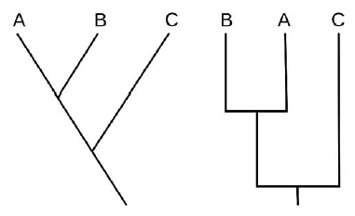 |  | Lesson Look Fors  Look for teachers to:  - Allow students to productively struggle with the content, using accountable talk moves to facilitate the lesson.  - Asking probing questions throughout the presentation that pushes students’ thinking.  Look for students to:  - Ask clarifying questions regarding what they are learning  - Write in complete sentences  Students Do and Know
  - Analyze data and identify trends.
  - Collaborate with peers to discuss similarities and differences in conclusions that were made.
  - An adaptation is a trait that an individual is born with that either gives it an advantage or disadvantage in an environment.
  - A cladogram is a diagram that shows the evolutionary relationships between organisms by grouping them into clades based on shared characteristics.
  - Homology is the study of similarities between organisms that are due to shared ancestry.
Lessons #12 and #13 – Speciation |  |  |  | Date:
Objective  SWBAT: Model the process where one species evolves into one or more separate species.  Standards  Topic 7.10: Speciation  Vocabulary  Speciation  Allopatric speciation  Sympatric speciation  Species  Reproductive isolation  Prezygotic barriers  Postzygotic barriers  Science Practices  - Concept Explanation  - Visual Representations  - Representing and Describing Data  - Argumentation | Instructional Notes  Learning Goal: Understand a genetic model of the evolution of reproductive incompatibility (and thus speciation).  Students whisper sentences to one another in a modified game of “telephone.” The lineage of sentences splits and diverges, and students record versions of sentences on notecards as the sentence evolves. After lineages finish evolving, students analyze how the sentences changed, how they relate to one another, and how the result relates to the DM model of reproductive incompatibility.  Methods of checking for understanding during/after the activity: Especially during small group discussions, there should periodically be “AHA!” moments from students in the groups. If those aren’t happening, it is likely that students are missing the links between the analogy and the model.  Tips or Comments for Instructors  - Monitor the whispering and try to keep it intimate between two individuals. If later individuals overhear the whisper at an earlier replication, it can bias the rate of “evolution.”  - Obviously, the number of replications and divergences depend on the number of students in the class. Depending on how many students are in each “lineage” (7-­‐8 worked with the example below) the instructor could vary the complexity in the sentences if the sentences needed to “evolve” more or less quickly.  Sample Sentences:  - And so there he was, upon his back in a leaky lifeboat in the middle of the Atlantic.  - He was optimistic about being rescued and enjoyed the dolphins frolicking about him.  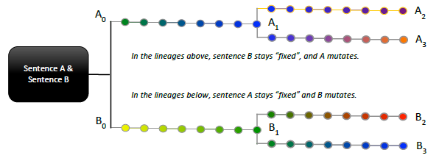 |  |  | Lesson Look Fors  Look for teachers to:  - Allow students to productively struggle with the content, using accountable talk moves to facilitate the lesson.  - Asking probing questions throughout the presentation that pushes students’ thinking.  Look for students to:  - Ask clarifying questions regarding what they are learning  - Write in complete sentences  Students Do and Know
  - Analyze data and identify trends.
  - Collaborate with peers to discuss similarities and differences in conclusions that were made.
  - Speciation is the process by which populations evolve into distinct species through the splitting of a single evolutionary lineage into two or more genetically independent lineages.
  - Allopatric speciation, also known as geographic speciation, is a process where biological populations become isolated and eventually evolve into new species.
  - Sympatric speciation is a process in evolutionary biology where a new species evolves from an existing species while both continue to live in the same geographic area.
  - Reproductive isolation is a set of barriers that prevent different species from breeding and producing healthy offspring.
Lessons #14 – Extinction |  |  |  | Date:
Objective  SWBAT: Investigate the cause of extinction events in a marine environment by analyzing multiple lines of scientific evidence to determine the most likely environmental factor responsible.  Standards  Topic 7.11: Variations in Populations  Vocabulary  Variation  Genetic diversity  Extinction  Science Practices  - Concept Explanation  - Visual Representations  - Questions and Methods  - Representing and Describing Data  - Statistical Tests and Data Analysis  - Argumentation | Instructional Notes  Activity:  In this forensic-style investigation, students analyze authentic marine data—such as microfossil abundances, sediment-core layers, isotope shifts, and geologic markers—to determine the primary cause of a marine extinction event. Students evaluate competing hypotheses (e.g., asteroid impact, volcanic activity, acidification, anoxic conditions), identify which evidence supports or contradicts each explanation, and rule out unlikely causes. Finally, students synthesize the evidence to construct a clear, scientific argument explaining the extinction event. This rigorous activity requires students to think like evolutionary ecologists and use evidence-based reasoning to identify the environmental change that led to species loss.   |  |  | Lesson Look Fors  Look for teachers to:  - Allow students to productively struggle with the content, using accountable talk moves to facilitate the lesson.  - Asking probing questions throughout the presentation that pushes students’ thinking.  Look for students to:  - Ask clarifying questions regarding what they are learning  - Write in complete sentences  Students Do and Know
  - Gather data needed
  - Analyze results and create correct conclusion
  - Genetic diversity is the variety of genes (alleles) within a species, crucial for adaptation, survival, and evolution, allowing populations to resist diseases, climate change, and other stresses because some individuals will have traits to cope, with key drivers being mutation, gene flow, natural selection, and genetic drift, while its loss threatens species and food security
  - Extinction is the complete disappearance of a species from Earth.
Lessons #15 – Origins of Life on Earth |  |  |  | Date:
Objective  SWBAT: Determine the correct order of how life evolved over the Earth’s lifespan based on previously learned concepts.  Standards  Topic 7.12: Origins of Life on Earth  Vocabulary  Evolution  RNA World Hypothesis  Organic molecules  Science Practices  - Concept Explanation  - Visual Representations  - Questions and Methods  - Representing and Describing Data  - Statistical Tests and Data Analysis  - Argumentation | Instructional Notes  Activity #1: Students will watch a video outlining the origins of life on Earth while filling out a thought catcher.  Activity #2: Mystery of the Chicken and the Egg Activity  This lesson is a wonderful collaborative activity where student groups put important events in Earth’s history in chronological order and then investigate through discussion certain trends that they find hidden in the constructed timeline. Students then condense the 4.6 billion years down to the size of a football field and place each event in the appropriate place, realizing the scale of time between these events. This lesson provides an amazing opportunity to have students investigate these events, how they are related to each other, and most importantly allows the students to experience how life and all of its components and characteristics are intimately interrelated.  Students will:  - Construct a timeline of important biological events through Earth’s history  - Explore abiotic and biotic trends in the timeline  - Experience the amount of time separating each event on a large expanse of space  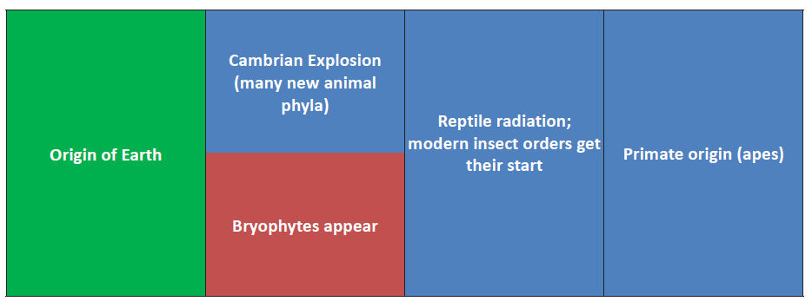 |  |  | Lesson Look Fors  Look for teachers to:  - Allow students to productively struggle with the content, using accountable talk moves to facilitate the lesson.  - Asking probing questions throughout the presentation that pushes students’ thinking.  Look for students to:  - Ask clarifying questions regarding what they are learning  - Write in complete sentences  Students Do and Know
  - Put geologic timescale cards in order from primitive to modern day.
  - Analyze data and identify trends.
  - Collaborate with peers to discuss similarities and differences in conclusions that were made.
  - Evolution is a change in gene frequencies in a population over time.
  - RNA World Hypothesis proposes that RNA could have been the earliest genetic material.
  - Organic molecules/monomers could have served as building blocks for the formation of more complex molecules, including amino acids and nucleotides.

Day 16 | Review for UE7
Day 17 | Administer UE7

UNPACKED STANDARDS
Focus standards for this unit.

Standards Clarification
Standards | Specificity | Notes/Explanations/Examples
7.1.A: Describe the causes of natural selection. | Cognition: Describe  Content: Provide relevant characteristics of a specified topic. | 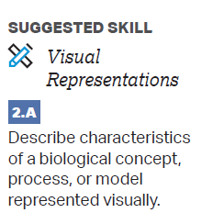  Classroom Resources:  Visualizing Information  Evolution and Change
7.1.B: Explain how natural selection affects populations. | Cognition: Explain  Content: Provide information about how or why a relationship, process, pattern, position, situation, or outcome occurs, using evidence and/or reasoning to support or qualify a claim. Explain “how” typically requires analyzing the relationship, process, pattern, position, situation, or outcome; whereas explain “why” typically requires analysis of motivations or reasons for the relationship, process, pattern, position, situation, or outcome.
7.2.A: Describe the importance of phenotypic variation in a population. | Cognition: Describe  Content: Provide relevant characteristics of a specified topic. | 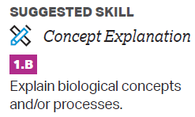  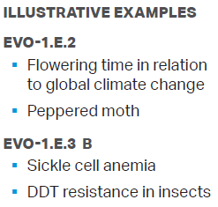  Classroom Resources:  Evolution and Change
7.2.B: Explain how variation in molecules within cells connects to the fitness of an organism. | Cognition: Explain  Content: Provide information about how or why a relationship, process, pattern, position, situation, or outcome occurs, using evidence and/or reasoning to support or qualify a claim. Explain “how” typically requires analyzing the relationship, process, pattern, position, situation, or outcome; whereas explain “why” typically requires analysis of motivations or reasons for the relationship, process, pattern, position, situation, or outcome.
7.3.A: Explain how humans can affect diversity within a population. | Cognition: Explain  Content: Provide information about how or why a relationship, process, pattern, position, situation, or outcome occurs, using evidence and/or reasoning to support or qualify a claim. Explain “how” typically requires analyzing the relationship, process, pattern, position, situation, or outcome; whereas explain “why” typically requires analysis of motivations or reasons for the relationship, process, pattern, position, situation, or outcome. | 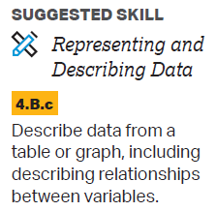  Classroom Resources:  Evolution and Change  Artificial Selection Lab
EVO-1.G: Explain the relationship between changes in the environment and evolutionary changes in the population. | Cognition: Explain  Content: Provide information about how or why a relationship, process, pattern, position, situation, or outcome occurs, using evidence and/or reasoning to support or qualify a claim. Explain “how” typically requires analyzing the relationship, process, pattern, position, situation, or outcome; whereas explain “why” typically requires analysis of motivations or reasons for the relationship, process, pattern, position, situation, or outcome.
7.4.A: Explain how random occurrences affect the genetic makeup of a population. | Cognition: Explain  Content: Provide information about how or why a relationship, process, pattern, position, situation, or outcome occurs, using evidence and/or reasoning to support or qualify a claim. Explain “how” typically requires analyzing the relationship, process, pattern, position, situation, or outcome; whereas explain “why” typically requires analysis of motivations or reasons for the relationship, process, pattern, position, situation, or outcome. | 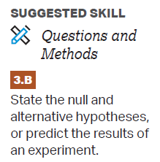  Classroom Resources:  Evolution and Change
7.4.B: Describe the role of random processes in the evolution of specific populations. | Cognition: Describe  Content: Provide relevant characteristics of a specified topic.
7.4.C: Describe the change in the genetic makeup of a population over time. | Cognition: Describe  Content: Provide relevant characteristics of a specified topic.
7.5.A: Describe the conditions under which allele and genotype frequencies will change in populations. | Cognition: Describe  Content: Provide relevant characteristics of a specified topic. | 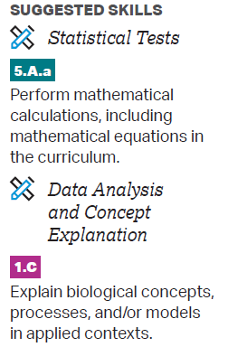  Classroom Resources  Evolution and Change  Mathematical Modeling  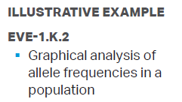
7.6.A: Describe the types of data that provide evidence for evolution. | Cognition: Describe  Content: Provide relevant characteristics of a specified topic. | 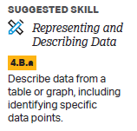  Classroom Resources  Evolution and Change
7.6.B: Explain how morphological, biochemical, and geological data provide evidence that organisms have changed over time. | Cognition: Explain  Content: Provide information about how or why a relationship, process, pattern, position, situation, or outcome occurs, using evidence and/or reasoning to support or qualify a claim. Explain “how” typically requires analyzing the relationship, process, pattern, position, situation, or outcome; whereas explain “why” typically requires analysis of motivations or reasons for the relationship, process, pattern, position, situation, or outcome.
7.7.A: Describe structural and functional evidence on cellular and molecular levels that provides evidence for the common ancestry of all eukaryotes. | Cognition: Describe  Content: Provide relevant characteristics of a specified topic. | 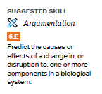  Classroom Resources  Evolution and Change
7.8.A: Explain how evolution is an ongoing process in all living organisms. | Cognition: Explain  Content: Provide information about how or why a relationship, process, pattern, position, situation, or outcome occurs, using evidence and/or reasoning to support or qualify a claim. Explain “how” typically requires analyzing the relationship, process, pattern, position, situation, or outcome; whereas explain “why” typically requires analysis of motivations or reasons for the relationship, process, pattern, position, situation, or outcome. | 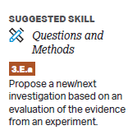  Classroom Resources  Evolution and Change
7.9.A: Describe the types of evidence that can be used to infer an evolutionary relationship. | Cognition: Describe  Content: Provide relevant characteristics of a specified topic. | 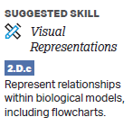  Classroom Resources  Evolution and Change
7.9.B: Explain how a phylogenetic tree and/or cladogram can be used to infer evolutionary relatedness. | Cognition: Explain  Content: Provide information about how or why a relationship, process, pattern, position, situation, or outcome occurs, using evidence and/or reasoning to support or qualify a claim. Explain “how” typically requires analyzing the relationship, process, pattern, position, situation, or outcome; whereas explain “why” typically requires analysis of motivations or reasons for the relationship, process, pattern, position, situation, or outcome.
7.10.A: Describe the conditions under which new species may arise. | Cognition: Describe  Content: Provide relevant characteristics of a specified topic. | 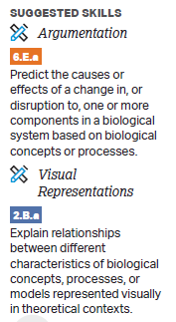  Classroom Resources  Evolution and Change  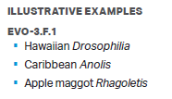
7.10.B: Describe the rate of evolution and speciation under different ecological conditions. | Cognition: Describe  Content: Provide relevant characteristics of a specified topic.
7.10.C: Explain the processes and mechanisms that drive speciation. | Cognition: Explain  Content: Provide information about how or why a relationship, process, pattern, position, situation, or outcome occurs, using evidence and/or reasoning to support or qualify a claim. Explain “how” typically requires analyzing the relationship, process, pattern, position, situation, or outcome; whereas explain “why” typically requires analysis of motivations or reasons for the relationship, process, pattern, position, situation, or outcome.
7.11.A: Explain how the genetic diversity of a species or population affects its ability to withstand environmental pressures. | Cognition: Explain  Content: Provide information about how or why a relationship, process, pattern, position, situation, or outcome occurs, using evidence and/or reasoning to support or qualify a claim. Explain “how” typically requires analyzing the relationship, process, pattern, position, situation, or outcome; whereas explain “why” typically requires analysis of motivations or reasons for the relationship, process, pattern, position, situation, or outcome. | 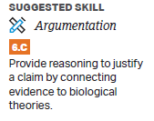  Classroom Resources  Evolution and Change  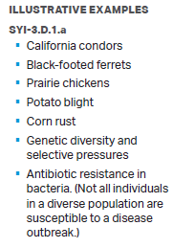
7.12.A: Describe the scientific evidence that provides support for models of the origin of life on Earth. | Cognition: Describe  Content: Provide relevant characteristics of a specified topic. | 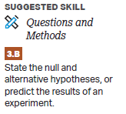  Classroom Resources  Evolution and Change

VOCABULARY GLOSSARY
Domain-specific words and definitions for this unit.
Key Content Vocabulary
Evolution – a change in the genetic composition of a population over successive generations

Speciation – The process in which new genetically distinct species evolve usually as a result of genetic isolation from the main population

Phylogeny – refers to the evolutionary history of the development of a species or of a taxonomic group of organisms. The phylogenetic relationships are depicted in the form of a phylogenetic tree, i.e., a tree diagram depicting how one taxon is closely or distantly related to another taxon. The tree diagram demonstrating phylogenetic relationships is based on the molecular sequencing data analyses as well as on morphological data matrices.

Cladogram – Cladograms are diagrams which depict the relationships between different groups of taxa called “clades.” By depicting these relationships, cladograms reconstruct the evolutionary history (phylogeny) of the taxa. Cladograms can also be called “phylogenies” or “trees.”

Natural Selection – a process in nature in which organisms possessing certain genotypic characteristics that make them better adjusted to an environment tend to survive, reproduce, increase in number or frequency, and therefore, are able to transmit and perpetuate their essential genotypic qualities to succeeding generations.

Fitness – The term "fitness" in evolutionary biology means the ability of an organism to pass on its genetic material to its offspring. Biological or "Darwinian" fitness is being able to live long enough to reproduce and keep the population or species alive.

Variation – defined as the presence of a various number of alleles with different distribution frequencies in a certain population. Genetic variation simply refers to the variation of genomes at the individual level (i.e., between individuals) or at the species level (i.e., between species populations).

Artificial selection – Artificial selection is the identification by humans of desirable traits in plants and animals, and the steps taken to enhance and perpetuate those traits in future generations.

Convergent evolution – concept in evolutionary biology that refers to the kind of evolution wherein, for instance, a pair of phylogenetically independent organisms evolve anatomically different structure, trait, or morphological feature that has the same function

Allopatric speciation – In allopatric speciation, because of population dispersion or a natural geologic event one species gets separated into different groups, and then they are divided into two different species. The geologic event can be the formation of mountains. Like the other types of speciation, allopatric speciation is typically a very slow process.

Sympatric speciation – refers to the evolutionary history of the development of a species or of a taxonomic group of organisms. The phylogenetic relationships are depicted in the form of a phylogenetic tree, i.e., a tree diagram depicting how one taxon is closely or distantly related to another taxon. The tree diagram demonstrating phylogenetic relationships is based on the molecular sequencing data analyses as well as on morphological data matrices.

Genetic drift – Genetic drift is a mechanism of evolution. It refers to random fluctuations in the frequencies of alleles from generation to generation due to chance events. Genetic drift can cause traits to be dominant or disappear from a population. The effects of genetic drift are most pronounced in small populations.

Bottleneck effect – The bottleneck effect describes the phenomenon when a population has a sudden reduction in the gene pool due to natural environmental events, natural disasters, disease, or human involvement. This reduction in the gene pool will likely cause a bias that did not exist in the original population.

Founders effect – The founder effect is the reduction in genetic variation that results when a small subset of a large population is used to establish a new colony. The new population may be very different from the original population, both in terms of its genotypes and phenotypes.

Gene flow – Gene flow is also called gene migration. Gene flow is the transfer of genetic material from one population to another. Gene flow can take place between two populations of the same species through migration and is mediated by reproduction and vertical gene transfer from parent to offspring.

Hardy-Weinberg Equilibrium – The Hardy-Weinberg equilibrium is a principle stating that the genetic variation in a population will remain constant from one generation to the next in the absence of disturbing factors.

Punctuated Equilibrium – the hypothesis that evolutionary development is marked by isolated episodes of rapid speciation between long periods of little or no change.

Gradualism – Gradualism in biology and geology refers most broadly to a theory that changes of organic life and of the Earth itself occur through gradual increments, and often that transitions between different states are more or less continual and slow rather than periodic and rapid.

Divergent evolution – process by which interbreeding species diverged into two or more evolutionary groups. It means that these groups of species used to be similar and related. However, they became increasingly dissimilar through time.

Adaptive Radiation – the diversification of a group of organisms into forms filling different ecological niches.

Extinction – Extinction is the dying out of a species. Extinction plays an important role in the evolution of life because it opens up opportunities for new species to emerge.

